**ASSIGNMENT – I**

**DOMAIN:-IOT**

**TOPIC:-SMART HOME**

**NAME:-JOB ALEX**

**REGISTER NUMBER:-961619104023**

**COLLEGE:-**MARTHANADAM COLLEGE OF ENGINEERING AND TECHNOLOGY

**SMART Home Circuit Connection:**

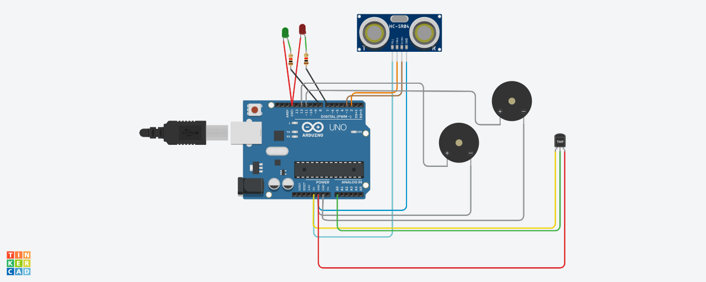

**COMPONENTS**

|  |  |
| --- | --- |
| **Quantity** | **Component** |
| 1 | Arduino Uno R3 |
| 1 | Red LED |
| 1 | Green LED |
| 1 | Temperature Sensor [TMP36] |
| 1 | Ultrasonic Distance Sensor |
| 2 | 1 kΩ Resistor |
| 2 | Piezo |

**CODE**

**int t=2;**

**int e=3;**

**void setup()**

**{**

**Serial.begin(9600);**

**pinMode(t,OUTPUT);**

**pinMode(e,INPUT);**

**pinMode(12,OUTPUT);**

**}**

**void loop()**

**{**

**//ultrasonic sensor**

**digitalWrite(t,LOW);**

**digitalWrite(t,HIGH);**

**delayMicroseconds(10);**

**digitalWrite(t,LOW);**

**float dur=pulseIn(e,HIGH);**

**float dis=(dur*0.0343)/2;**

**Serial.print("Distance is: ");**

**Serial.println(dis);**

**//LED ON**

**if(dis>=100)**

**{**

**digitalWrite(8,HIGH);**

**digitalWrite(7,HIGH);**

**}**

**//Buzzer For ultrasonic Sensor**

**if(dis>=100)**

**{**

**for(int i=0; i<=30000; i=i+10)**

**{**

**tone(12,i);**

**delay(1000);**

**noTone(12);**

**delay(1000);**

**}**

**}**

**//Temperate Sensor**

**double a= analogRead(A0);**

**double t=(((a/1024)*5)-0.5)*100;**

**Serial.print("Temp Value: ");**

**Serial.println(t);**

**delay(1000);**

**//LED ON**

**if(t>=100)**

**{**

**digitalWrite(8,HIGH);**

**digitalWrite(7,HIGH);**

**}**

**//Buzzer for Temperature Sensor**

**if(t>=100)**

**{**

**for(int i=0; i<=30000; i=i+10)**

**{**

**tone(12,i);**

**delay(1000);**

**noTone(12);**

**delay(1000);**

**}**

**}**

**//LED OFF**

**if(t<100)**

**{**

**digitalWrite(8,LOW);**

**digitalWrite(7,LOW);**

**}**

**}**

**LINK:-**  **https://www.tinkercad.com/things/5oYUzWZ7OkA-surprising-crift-borwo/editel?tenant=circuits**